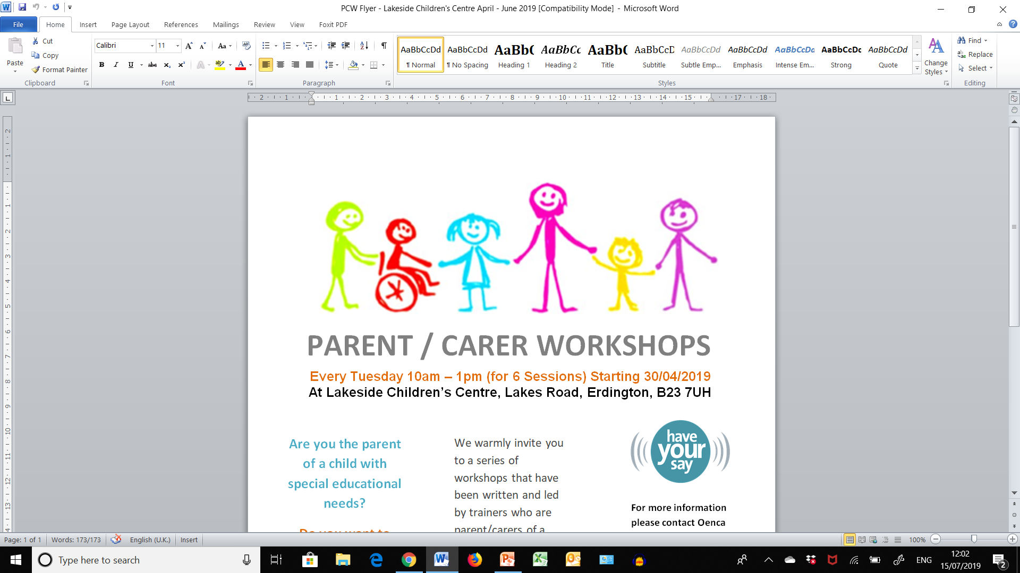

**Be Empowered** **Workshop** – Early Support Programme for SEND Parent Carers

**Every Wednesday Evening from 6-9pm for 6 weekly sessions**

**Starting Wed 22nd April; Wed 29th April; Wed 6th May; Wed 13th May; Wed 20th May but NOT 27TH MAY AS HALF TERM and finally Wed 3rd June**

**We warmly invite you to join in online to a series of evening workshops that have been written and led by trainers who are parent/carers of a child with additional needs themselves.**

**These workshops are for parent/carers of children and young people of any age, with any additional need following diagnosis. They are an attempt to support parent/carers through times of change and at whatever stage of the journey participants may find themselves.**

**For more information please contact Oenca Fontaine (Parent Engagement Consultant)** [oenca@innerdimensions.co.uk](mailto:oenca@innerdimensions.co.uk) or **Sarah Adams (EYIS – Early Support Service)** [Sarah.Adams@birmingham.gov.uk/](mailto:Sarah.Adams@birmingham.gov.uk/) 07827 082751

**To book, please complete and sign attached booking form and consent and email to either Sarah Adams or Oenca Fontaine.**

**DUE TO THE CURRENT COVID-19 SITUATION, THE ABOVE WORKSHOPS WERE DUE TO TAKE PLACE AT MOSELEY HALL HOSPITAL ON THE ABOVE DATES/TIMES. THESE WORKSHOPS ARE NOW GOING TO BE OFFERED VIA VIDEO-CONFERENCING.**

**IF YOU ARE INTERESTED IN ACCESSING THESE WORKSHOPS AND HAVE A PC OR LAPTOP WITH A CAMERA AT HOME, PLEASE STILL APPLY VIA EMAILING THE ATTACHED BOOKING FORMS TO EITHER SARAH ADAMS OR OENCA FONTAINE AT THE ADDRESSES BELOW.**

**NB: IF THE CURRENT COVID-19 SITUATION CONTINUES, WE INTEND TO OFFER THE BEW SESSIONS PLANNED FOR LAKESIDE CC, IN THE SAME WAY!**

